Reformation Day.

October 31st 1517.
509 Years Ago.

Martin Luther
1483 – 1546
Roman Catholic Monk
Translated the Bible into German.
Discovered Error of Rome.
Wrote 95 Thesis

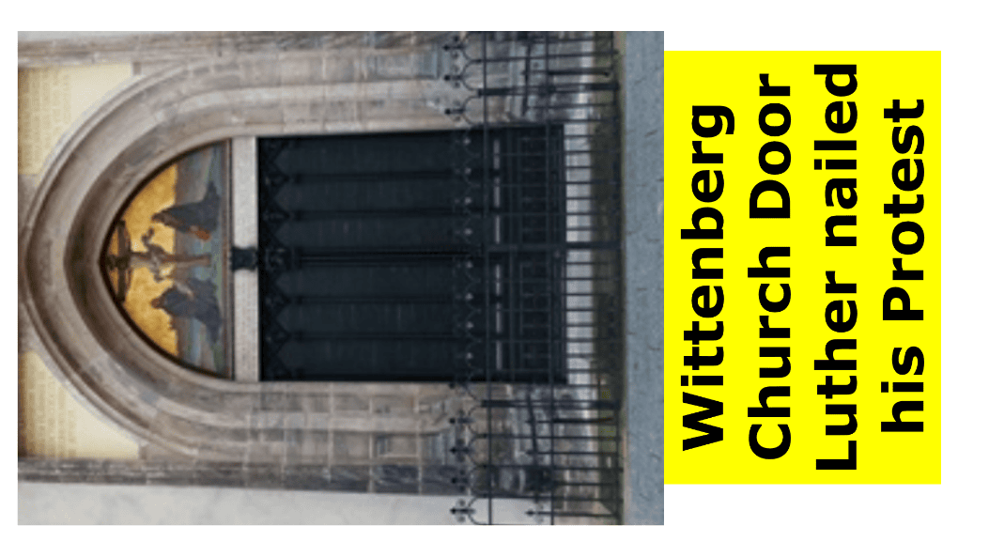
Roman Catholic Errors.
The Pope, Priests, Mary, Confessions, Purgatory, Penance, Idols.
All man-made ideas.
Not in the Bible.
The 5 Sola’s of The Reformation.
Sola – Only, Alone
- By Grace alone (Sola Gratia)
- Through Faith alone (Sola Fide)
- In Christ alone (Sola Christus)
- According to Scripture alone (Sola Scriptura)
- For God’s Glory alone (Sola Deo Gloria)
A return to the beliefs held by the early Church -AD33 to about AD450.
- By Grace alone (Sola Gratia)
See Ephesians 2v8,9, and v5.
“Even when we were dead in sins, hath quickened us together with Christ, (by grace ye are saved.)”

G - God’s
R - Riches
A - At
C - Christ’s
E – Expense

- Through Faith alone (Sola Fide)
“But that no man is justified by the law in the sight of God, it is evident: for, The just shall live by faith.” Gal 3v7.
F - Forsaking
A - All
I - I
T - Trust
H - Him
- In Christ alone (Sola Christus)
“Jesus saith, I am The Way, The Truth, and The Life: no man cometh unto the Father, but by Me.” John 14v6.
2 Timothy 2v5 says,
“For there is one God, and one mediator between God and men, the Man Christ Jesus.”

Acts 4v12 says,
“Neither is there salvation in any other: for there is none other name under heaven given among men, whereby we must be saved.”
Christ died to save sinners, rose again and ascended to present them to His Father
- According to Scripture alone (Sola Scriptura)
Our Basis of Faith says,
We believe in, the full inspiration of the Holy Scriptures; their authority and sufficiency as not only containing but as being in themselves the Word of God. The reliability of the Scripture witness to itself as the only, the complete and infallible Word of God, the New Testament witnessing to the reliability and divine character of the Old Testament; the necessity also for a reverent faith in the Word, and the teaching of the Holy Spirit, for a true understanding of the whole.
2 Timothy 3v16,17.
“All scripture is given by inspiration of God, and is profitable for doctrine, for reproof, for correction, for instruction in righteousness:
That the man of God may be perfect, thoroughly furnished unto all good works.”
- For God’s Glory alone (Sola Deo Gloria)
1 Peter 4v11 says,
“If any man speak, let him speak as the oracles of God; if any man minister, let him do it as of the ability which God giveth: that God in all things may be glorified through Jesus Christ, to whom be praise and dominion for ever and ever. Amen.”
God’s free gift of faith and repentance brings glory to Himself.
Christ’s death on the cross brings glory to The Father.
The quickening work of The Holy Spirit brings glory to God as sinners are born again and adopted into God’s Family.

In conclusion.
The Holy Spirit re-awakened the church so that we can know, understand, love, and believe these vital Biblical Doctrines.
Let us live them out and continue to preach them to the salvation of souls and the glory of God.

A Bible Study on this subject is on the EDT Website at
https://eastdulwichtabernacle.org/Rom/The-Five-Solae-of-the-Reformation

