Bible\College Class Notes – God’s Great Plans – Lesson 26
God Begins a Plan for Abraham.
This week we learn about Faith, and that nothing is too difficult for the Lord to perform.
Teaching Notes
“Is anything too hard for the Lord?” Genesis 18v14
Today we will learn: -
- What the Bible means by Faith.
- How we can please God.
- How we can become a Christian.

God Calls Abram – He Has a Plan for His Life.
The Call of Abram by God.
Our Timeline is 2,000 years before the birth of Christ.
That is about 4,000 years ago.
Ur of the Chaldees, in Babylonia
which is in modern day Iraq, is now in ruins.
Watch Pastor’s Video Clip (Ur mentioned ½ way through)
https://eastdulwichtabernacle.org/exploring-christianity/Heritage-of-Evidence/Nebuchadnezzar-and-Ur-of-the-Chaldees

At this time Ur was the Leading City of the world.
A sophisticated city with 2 storey houses,
civic buildings, busy streets, libraries, schools, banks, mains drainage, and
a commercial system of trading with money, receipts.
The people of Ur knew how to make glass.
The people were idol worshippers – The moon goddess.
Worshipping Idol gods from Nature: -
Fire, Sun, Moon, Stars, and Forces of Nature.
Promoting sinful immorality.
Very similar to the evils of today.

Abram was called by God to take his family,
including his father Terah,
out of idolatrous Ur.
and travel northwest to Haran.
2
How did Abram know about the One, True, God?
He lived in the area where the Garden of Eden was.
It was 1656 years from Adam to the Flood when Noah was 600.
Adam’s life, (930 years), overlapped Methuselah (who lived 969 years), by 243 years, so Methuselah gave an account of Creation and The Fall from Adam, to Noah.
Adam died 126 years before the birth of Noah.
Methuselah’s life overlapped Noah, (who lived 950 years), by 600 years, dying just before the Flood.
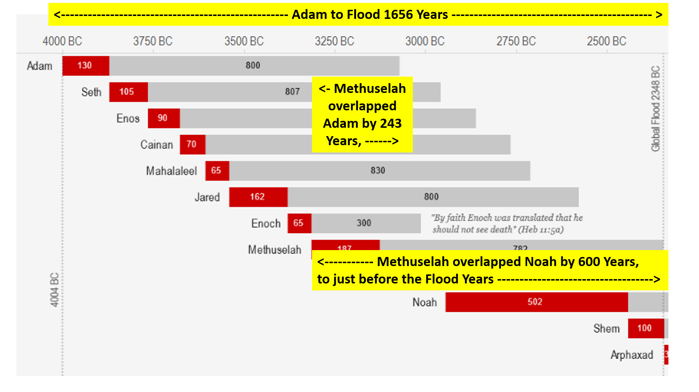
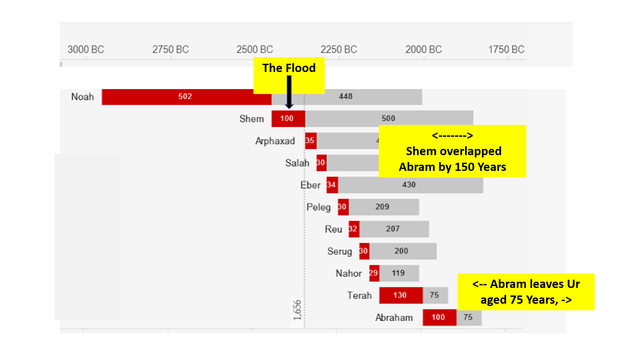
Noah died 2 years before the birth of Abram.
Shem, Noah’s son, (lived 600 years), overlapping Methuselah by 98 years, and Abram by 150 years.
So, Shem was able to tell Abram first-hand about the Flood, and historically about Creation.

So, Noah died at about the time that Abram was born.
3
So, much truth about God had been passed on orally.
Abram believed in and worshipped The One True God.
God also worked in the heart of Abram to teach him.
God the Holy Spirit had given Abram faith.

- God Calls Abram Out of Ur of the Chaldees
to The Land of Canaan.
Now the Lord had said unto Abram, “Get thee out of thy country, and from thy kindred, and from thy father's house, unto a land that I will shew thee: And I will make of thee a great nation, and I will bless thee, and make thy name great; and thou shalt be a blessing: …... and in thee shall all families of the earth be blessed.” Genesis 12v1-3.

God gives Abram Faith.
and encourages him to obey and put it into practice.
As we have seen, sophisticated Ur was a centre of idol worship.
It was an evil place to live. Abram knew he had to leave Ur.
The Lord, in His Word, teaches us to leave the way of the world,
for it is sinful and detrimental to the welfare of our soul.
Abram obeyed and left Ur
with his father Terah, an idol worshipper,
and took his family to Haran, 600 miles northwest.
The ruin of Haran is in modern day Turkey,
600 miles northwest of Ur. VA Map
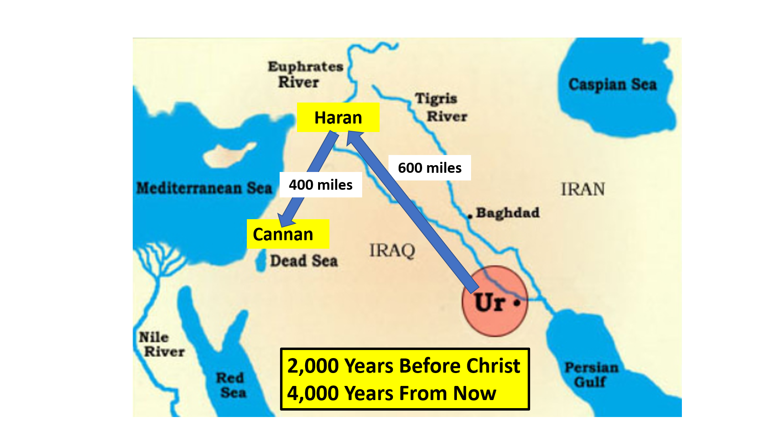
4
Haran was a well settled area with trade routes to Babylon, Assyria, Egypt.
It was still too sinful a place for Abram to live.
God had promised to make a great nation

When Abram was 75 years old his father Terah died and Abram, by faith, left Haran in search of a more sparsely populated area.
We see that Abram’s faith was for the future: -
Where he would live now
Where his family would live in the future
Where all the families of the earth will be blessed
The Saviour would be born to Mary.
And he would live eternally in Heaven.

“By faith Abraham when he was called to go out into
a place which he should after receive for an inheritance,
obeyed; and he went out, not knowing whither he went.
By faith he sojourned in the land of promise, as in a strange country, dwelling in tabernacles with Isaac and Jacob,
the heirs with him of the same promise:
For he looked for a city which hath foundations,
whose builder and maker is God.” Hebrews 11v8-10.

- What is Faith?
A mix of Fear (awe) and Humble Respect for the Lord.
Abraham knew in his soul, (and so can we): -
He had offended God by breaking His holy law.
He was a guilty sinner in God’s holy, all-searching,
and all-knowing sight.
That God is the Almighty Creator
and the Righteous Judge of all the earth.
He must Repent his sin, seek Forgiveness,
Believe in, Trust, and Obey His Creator, and Saviour.

The first lesson we learn from Abram’s faith
is that we too must become ‘afraid’.
Afraid of the Judgement of sin by the Holy God.

5
John Bunyan wrote in Pilgrim’s Progress
We live in the City of Destruction.
Pilgrim had to flee from it
and make his way to the Celestial City – Heaven
We must realise that we too, live in this doomed world,
where nothing is sure and reliable, as in the City of Destruction.

We must wake up to the certain fact that, one day, God will judge all people who have wilfully and arrogantly disobeyed Him.
We must do more than say, “I believe in God.”
We must ask Him to so work in our hearts that we begin to feel our great need to be saved from the guilt of our sin.

This is what Abram was doing when he left Ur and Haran. ??

- Faith – Not Good Works to Please God
but Obedient Trust In Him.
Natural man – before conversion to Christ,
wants to make his own way to God.
Beware, our pride tells us we can make our own way to Heaven.
BUT this cannot be. God has declared His way.
Jesus said, “I am the way, the truth, and the life:
no man cometh unto the Father, but by Me.”

Abraham showed no confidence in himself.
He did not argue his own goodness (works).
He humbly obeyed God in repentance and faith.

Some teach that because God has made us responsible
to come to Him that we are able to do this.
The Bible describes us as being ‘dead in sin’ Ephesians 2v1-3
“And you hath he quickened, who were dead in trespasses and sins; Wherein in time past ye walked according to the course of this world, according to the prince of the power of the air, the spirit that now worketh in the children of disobedience:
Among whom also we all had our conversation (manner of life), in times past in the lusts of our flesh, fulfilling the desires of the flesh and of the mind; and were by nature the children of wrath, even as others.”

6
Being spiritually dead we cannot come to God.
Dead means dead. No spiritual life at all.
Beware, trying to work our own way to Heaven is a disastrous policy.
Ephesians 2v4-6, tells us of the love and grace of God: -“But God, who is rich in mercy,
for His great love wherewith He loved us,
Even when we were dead in sins, hath quickened us together with Christ, (by grace ye are saved;)
And hath raised us up together, and made us
sit together in heavenly places in Christ Jesus.”
It is Faith in Christ alone that saves.

- Faith – Leads us to Separation from this Evil World of Sin.
God called Abraham to leave - Ur of The Chaldees, Haran,
and his family and friends, his old way of life –
To travel to an unknown Promised Land.
Would Abram be really prepared to do this?

He would have to leave the comfort of his house in Haran,
And acquire tents for him and his family to live in.
He and his family were to become Nomads,
– with no fixed abode.
When we are converted then we have to turn our back on what previously interested us in the world.
Some friends will have to go, reading habits must change, Worldly entertainments abandoned.

- Faith – Is Receiving God’s Promises and their Conditions.
God Promised Abraham (aged 75 when he left Haran): -
Remain Faithful and: -
In time a New Land for his family,
and an Eternal Home, Heaven.
He would make his descendants a Great Nation
and protect them.
One of his descendants would be
The Lord Jesus Christ – The Saviour.

Abram would know ‘solid joys, and lasting treasure.’
7
So does the faithful Christian. We can know: -
Relief of knowing that all our sins are forgiven.
Peace and reconciliation with our Holy God.
Joy of knowing the Lord Jesus as personal Saviour.
That the filthy rags of our sin are replaced
by the righteousness of the Lord Jesus.
The sure guidance of His Word.
Free access to God in prayer.
The protection of the Lord from all our enemies.
The privilege of representing the King of Kings
to others around us.
The sure and certain hope of eternal Heaven.

- Faith – Is Believing that God Can Do the Impossible.
Abram enjoyed a beautiful land which provided -
good pasture and grew good crops.
Abram received protection from his enemies.

God makes a Covenant (Agreement) with Faithful Abram.
And when Abram was ninety years old and nine, the Lord appeared to Abram, and said unto him, I am the Almighty God; walk before Me, and be thou perfect. And I will make My covenant between Me and thee, and will multiply thee exceedingly.
Abram believed God’s promise of a son, Isaac, even though he would be 100, and Sarah, his wife, 90 years old
- well past child-bearing age.
Abram believed that Nothing is too hard for the Lord.

- Faith – The Gift of God Given by The Holy Spirit. Ephesians 2v8,9
Where Paul wrote, “For by grace are ye saved through faith; and that not of yourselves: it is the gift of God: Not of works, lest any man should boast.”

- Pray to God, Ask Him for His Gift of Faith and Repentance.
8
Exercise Faith Daily – By Repentance - believing that The Lord Jesus Christ died in your place to be your Saviour. Faith to read the Bible, Pray, Obey, Witness, Grow in Grace, and Sanctification (our aim to be more Christ-like).
Beware – Falling into Sin and Disobedience will forfeit God’s Joy and Peace, but if we have been given Faith, then God will gladly receive us when we return to Him with repentant hearts.

Those who have been given Faith will never lose their Salvation, nor their eternal home in Heaven to come.
We will sin but God will bring us back to repentance,

God changed his name to Abraham –
(Father of many nations). Gen 17v5

Important Lesson for us today :
Faith is a gift from God. Ephesians 2v8,9.
Due to Adam’s Fall (read Genesis 3), we inherit a spiritual deadness towards God, so, being spiritually dead, we cannot generate faith within ourselves.
We must prayerfully seek it from God and then exercise it.
You will know when God has given you Faith as you will be troubled by your sin.
Then Faith will lead you to repentance, and your acceptance that the Eternal, Holy God created all things by the Word of His Power.
Faith brings us to humbly believe that Jesus Christ, as our Saviour and Lord, died on the cross as our substitute.
At first, like Abraham, we will make mistakes, but faith will cause us to ask for forgiveness and guidance in life – to bring us back to God to live lives pleasing to Him.
We approach the same God today for He never changes. Seek Him now in repentant prayer.

