Bible Class Notes - Lesson 184 God’s Purpose
God’s Final Work - To Fit Us For Heaven.
Teaching Notes
“Whom He did predestinate, them He also called: and whom He called, them He also justified: and whom He justified, them He also glorified.” Romans 8v30 VA
How God Fits Us For Heaven – He Glorifies Us.
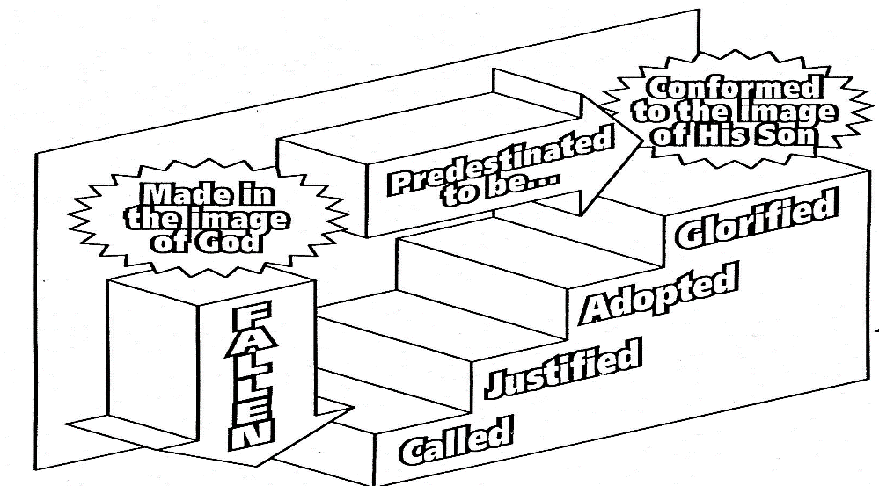

2

Revision. God Fits His People for Heaven Despite a Great Fall: - As descendants of Adam we are all Fallen, Lost in Sin, and Enemies of God. You remember that Adam tarnished his soul when he disobeyed God. He lost his close relationship with his Creator.

We have all inherited that sinful nature. We naturally live in rebellion to God, in unbelief – sinners.
This means we do not enjoy God and that we will not be able to enter God’s holy Heaven to enjoy Him for ever.
The guilt of our sin shuts us out. Does this worry you?
You may ask, “Am I lost for ever?”
Thankfully, No God has provided a solution, a way of escape.
Refer to VA Steps to Heaven Diagram Only those who are Glorified (conformed to the Image of His Son, the Lord Jesus Christ) can enter Heaven.
Adam fell by being disobedient. Lost his pure image.
So, what does it mean to be Glorified and how can we be Glorified? We certainly cannot remove the guilt of our sin and glorify ourselves. It is all the gracious work of God through the Saving work of the Lord Jesus Christ.
This is the way God does this wonderful and marvelous work in the soul of a lost sinner: -
3
We must come as Believers, (being Predestinated (chosen) by God in eternity past), to be Glorified.
God Graciously Calls us. Called by God The Holy Spirit. VA Revision Invitations 1 Isaiah 45v22 Look to the Saviour 2 Acts 2v21 Call out for forgiveness 3 Romans 10v9 Confess our sin, repent, believe 4 Isaiah 55v1 Come, buy without money 5 Matthew 11v28 Obtain rest to your soul
This calling includes God’s gift of Faith causing us to Repent and Believe on the Lord Jesus Christ as our Saviour, (the Lord named it being Born Again).
This is a New Birth experience which restores us from the tarnished image inherited from Adam so as to be made spiritually alive (Born Again). This, in turn, enables us to repent and believe in the Lord Jesus Christ as our Saviour.
John 3v3-8 tells us of this wonderful experience. Jesus answered and said unto him, “Verily, verily, I say unto thee, Except a man be born again, he cannot see the kingdom of God. Nicodemus saith unto him, “How can a man be born when he is old? can he enter the second time into his mother's womb, and be born?” Jesus answered, “Verily, verily, I say unto thee, Except a man be born of water and of the Spirit, he cannot enter into the kingdom of God. That which is born of the flesh is flesh; and that which is born of the Spirit is spirit. Marvel not that I said unto thee, Ye must be born again.
4
The wind bloweth where it listeth, and thou hearest the sound thereof, but canst not tell whence it cometh, and whither it goeth: so is every one that is born of the Spirit.” VA
The Lord Jesus clearly teaches us that the New Birth is a miraculous work of the Holy Spirit.
Just as we had no part in our physical conception and birth so we have no initiating involvement in our New Birth. The Lord likens this work of the Holy Spirit to the wind. The wind blows – we cannot see it but we can hear it, feel it, and see that it moves things.
So, we cannot see the Holy Spirit but we can see the change He makes in a sinners’ heart, renewing them and bringing them to the Saviour.
When we have faith and truly believe that Christ died on the cross to take away the guilt of our sin then God declares us to be Justified (declared righteous) in His Holy sight.
Justified (just as if I’d) never sinned.
What a marvelous and wonderful transaction! What does the Saviour take away and what does He give us in its’ place?
The exchange of our sin and its’ guilt VA for the perfect righteousness of the Lord Jesus.
God’s holy wrath against our sin and against us as sinners has been dealt with. Binding and Legally Satisfied. He, as perfect God and perfect Man, cancels the guilt of our sin and gives us in exchange His righteousness so that we are made right with God.
5
We are Adopted by God into His family. VA Again, a Sovereign work of God. A child does not choose to be adopted. It is their potential adopted-parents who choose them.

But God’s Adoption is different in that He does not pick the most beautiful, or the most intelligent.
His Adopting love for each of His Elect was settled in Eternity Past and was out of pure love. Having predestinated us unto the adoption of children by Jesus Christ to Himself, according to the good pleasure of His will. Ephesians 1v5
None of us deserve His Adopting Love. Romans 5v8 But God commendeth his love toward us, in that, while we were yet sinners, Christ died for us. Those who are Called, Justified, Adopted must grow like the Lord Jesus Christ in Sanctification (Holiness), and finally, to be Glorified (changed for ever to be like Christ) – Made Perfect, to enjoy God’s Eternal Heaven for ever.

The believer is no longer afraid of death, OR of Christs’ return in Judgement. Death for the Believer is the Gateway and Entrance to God’s Eternal Heaven.

The Lord Jesus Died for Lost Sinners, Rose Again, and Ascended into Heaven, promising to return.
He will Come Again as Judge of All on Judgement Day – Resurrection Day.
On that day Believers will be given new, glorified bodies; fitted to enjoy God in His New Heaven and New Earth
forever.

6
Glorified with The Exalted Christ.
What a glorious experience this will be!

Glorify – “to magnify, to extol, to praise”, especially of “glorifying” God, i.e., ascribing honour to Him,
acknowledging Him as to His Holy being,
His attributes of love, mercy, and grace,
and His acts of kindness, especially in saving us.

We need to be sinless to Glorify God.

How are Believers, who were once Dead in Sin, Glorified in Death? What does this mean? 1 Corinthians 15v42-44. VA So also, is the resurrection of the dead. It is sown in Corruption; it is raised in Incorruption: It is sown in Dishonour; it is raised in Glory: it is sown in Weakness; it is raised in Power: It is sown a Natural body; it is raised a Spiritual body. There is a natural body, and there is a spiritual body.
‘Sown’ in Corruption – Life in this World is dominated and corrupted by Sin and Death,
BUT the believer is Raised by God in Incorruption – Made New in Christ, Perfect, Sinless, Justified.
‘Sown’ in Dishonour – Our Sin is Ugly, bringing Dishonour and Death to our Soul and Body,
BUT the believer is Raised by God in Glory– Adopted, Perfected by God to Enjoy Him for Eternity.
‘Sown’ in Weakness – We have no Power in this Life over Sin, and Death,
BUT the believer is Raised by God in Power – No more Sin for the Believer. Glorified. Oh, What Joy!
7
The Lord Jesus said, “The hour is coming, in the which all that are in the graves shall hear His voice, and shall come forth; they that have done good, (repented and believed in Christ),
unto the resurrection of life (Entrance into Heaven); and those that have done evil, (rejecting Jesus Christ as Saviour),
unto the resurrection of damnation (Hell).” John 5v28-29

Made to be like the Lord Jesus Christ – Pure, Holy.

Important Lesson for us today:
Let us glory in the Salvation of God which the Lord Jesus Christ achieved for His Elect People, dying on their behalf on the Cross of Calvary.
Those for whom Christ died were: -
Predestinated (Chosen by God) in eternity past,
Called from their lost sinful state by the Holy Spirit, Justified by grace (Christ died to remove all their sin), Adopted into the family of God through the New Birth, and Gloriously restored to the perfect image of the Lord Jesus Christ, God The Son.

Is this your experience?

Have you heard in your conscience the Call of God to repent and believe?
“Come unto Me all ye that are heavy laden, and I will give you rest”. Matthew 11v28
“Ho, every one that thirsteth, come ye to the waters, and he that hath no money; come ye, buy, and eat;
yea, come, buy wine and milk without money and without price”. Isaiah 55v1

